DATA FLOW DIAGRAM FOR ONLINE STORE **ARTISANAL**

Request

0.0

Response

Request

ARTISANAL

Response

Request

Online shop

Response

CUSTOMER

ADMIN

SELLER

*Submitted by, Sinju Mathews On -07-2023*

DFD- LEVEL 0

DFD- LEVEL 1

# Admin side

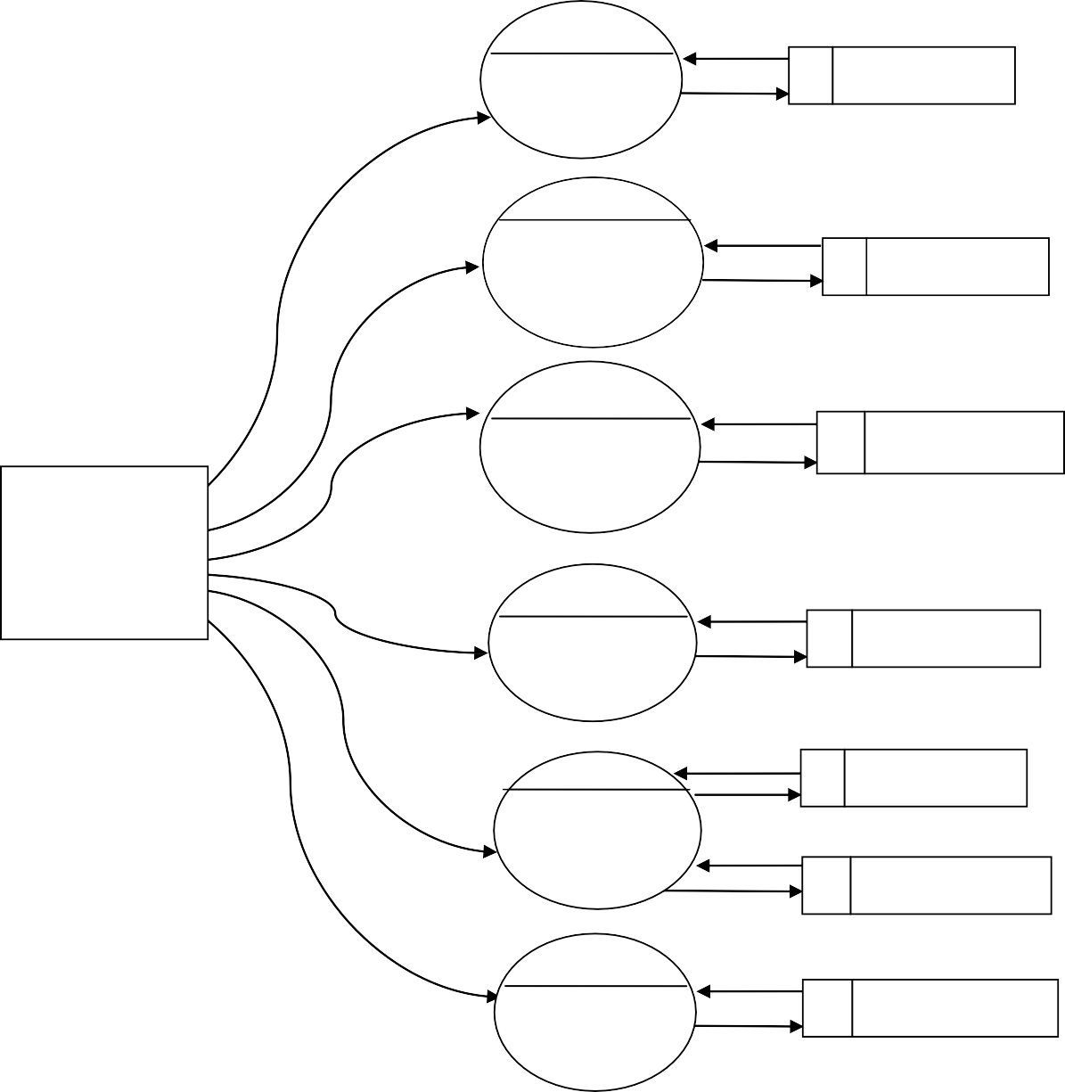

1.0

Login

tbl_admin

2.0

Manage Category

tbl_category

3.0

Manage products

tbl_product

ADMIN

4.0

Manage Stock

tbl_stock

5.0

Manage Reports

tbl_product

tbl_order

6.0

Manage complaints

tbl_complaint

1. *Seller side*

1.0

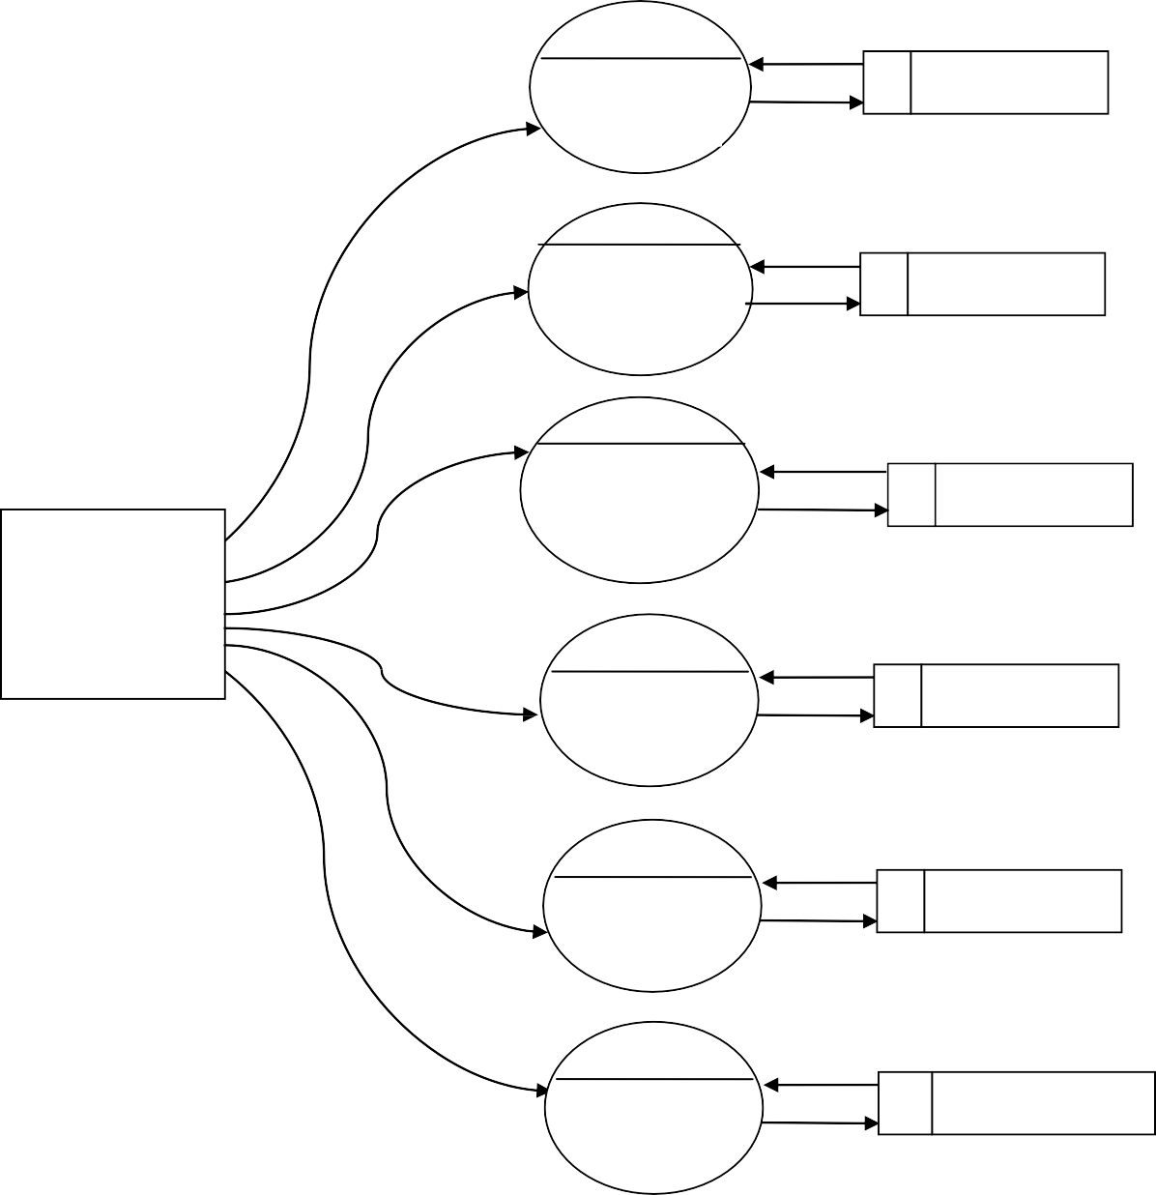

Sign in

tbl_seller

2.0

Login

tbl_seller

3.0

Manage Account

tbl_seller

SELLER

4.0

Manage products

tbl_product

5.0

Manage orders

tbl_order

6.0

Sent complaint

tbl_complaint

# Customer Side

1.0

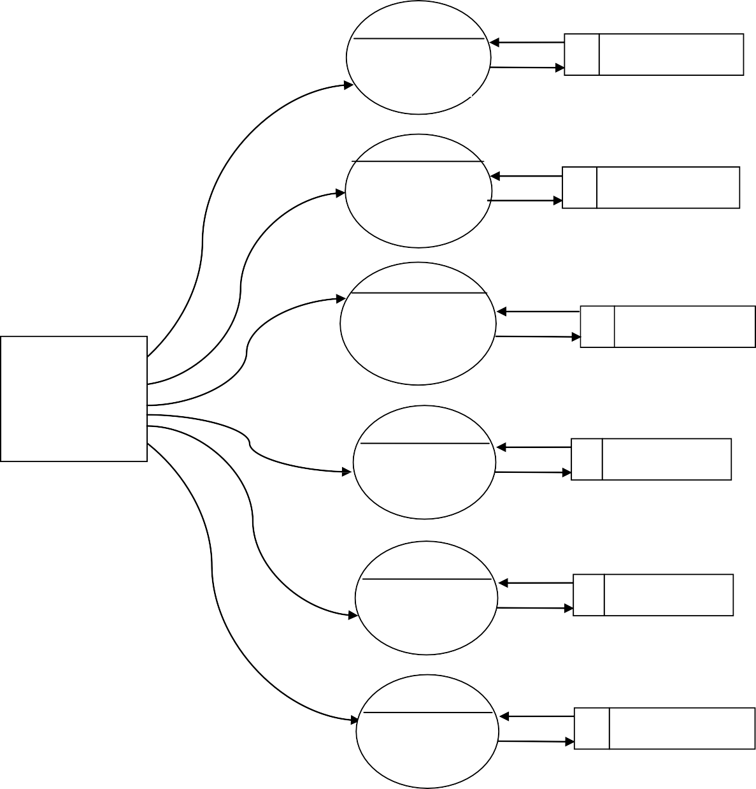

Sign in

tbl_customer

2.0

Login

tbl_customer

3.0

Manage Account

tbl_customer

CUSTOMER

4.0

view products

tbl_product

5.0

Make orders

tbl_order

6.0

Sent feedbacks

tbl_feedback

DFD - LEVEL 2

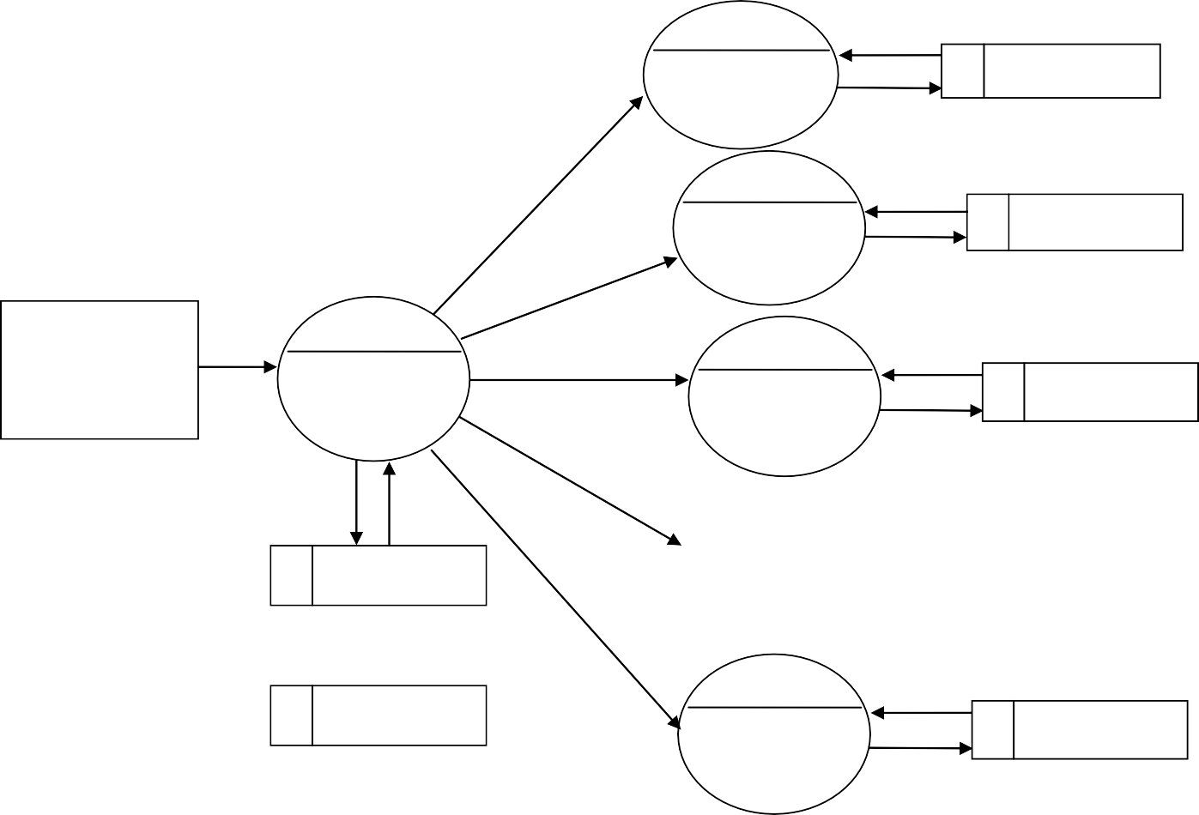

5.1

customer report

tbl_customer

5.2

Seller report

tbl_seller

5.0

ADMIN

5.3

Manage

Reports

product

report

tbl_product

5.2

tbl_product

order

report

tbl_order

5.3

tbl_order

payment

report

tbl_payment

1. *Admin Side*

2.1

add categories

tbl_category

2.0

2.2

Manage

categories

edit

categories

tbl_category

tbl_category

2.3

delete categories

tbl_category

ADMIN

1. *Seller side*

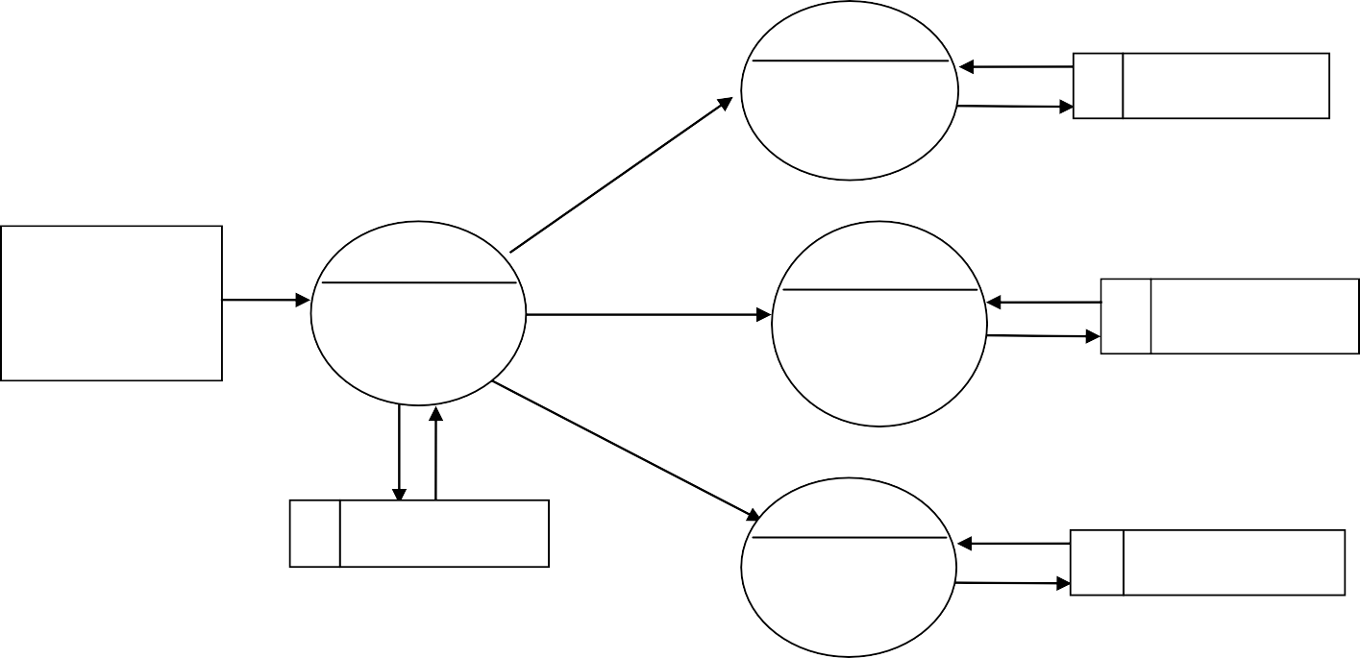

6.1

View customer

complaint

tbl_complaint

6.0

6.2

ADMIN

view

complaint

View seller

complaint

tbl_complaint

tbl_complaint

6.3

Reply to complaints

tbl_complaint

3.1

view account

tbl_seller

3.0

3.2

Manage

account

edit

account

tbl_seller

tbl_seller

3.3

delete account

tbl_seller

SELLER

4.1

add products

tbl_product

4.0

4.2

Manage

products

Update

products

tbl_product

tbl_product

4.3

remove products

tbl_product

SELLER

5.1

view order

tbl_order

5.0

5.2

Manage

orders

Confirm

/cancel order

tbl_order

tbl_order

5.3

Dispatch order

tbl_order

SELLER

1. *Customer side*

3.1

view account

tbl_customer

3.0

3.2

Manage

account

edit

account

tbl_customer

tbl_customer

3.3

delete account

tbl_customer

CUSTOMER

4.1

view product

tbl_product

4.0

4.2

view

products

add to

wishlist

tbl_wishlist

tbl_product

4.3

Add to cart

tbl_cart

CUSTOMER

5.1

confirm order

tbl_order

5.0

5.2

Make

orders

Make

Payment

tbl_payment

tbl_order

5.3

View/cancel order

tbl_order

CUSTOMER